# **POLITICAL JUGGERNAUTS: A QUANTITATIVE ANALYSIS OF CANDIDATES IN THE 2019 LOK SABHA ELECTIONS**

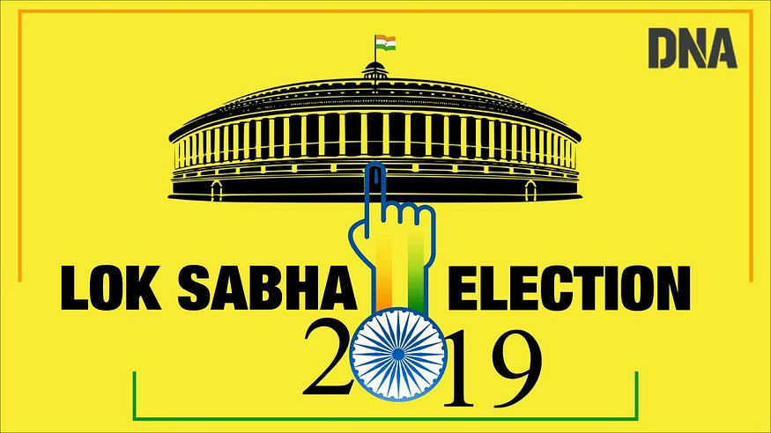

1.INTRODUCTION:

* **The Lok Sabha is composed of representatives of people chosen by direct election on the basis of Universal Adult Suffrage. The Constitution of India allows for a maximum of 550 members in the House, with 530 members representing the States and 20 representing the Union Territories. The 17th Lok Sabha was formed by the members elected in the 2019 Indian general election. Elections, all across India, were conducted in seven phases from 11 April 2019 to 19 May 2019 by the Election Commission of India.**
* **The Bharatiya Janata Party received 37.36% of the vote, the highest vote share by a political party since the 1989 general election, and won 303 seats, further increasing its substantial majority. In addition, the BJP-led National Democratic Alliance (NDA) won 353 seats.**

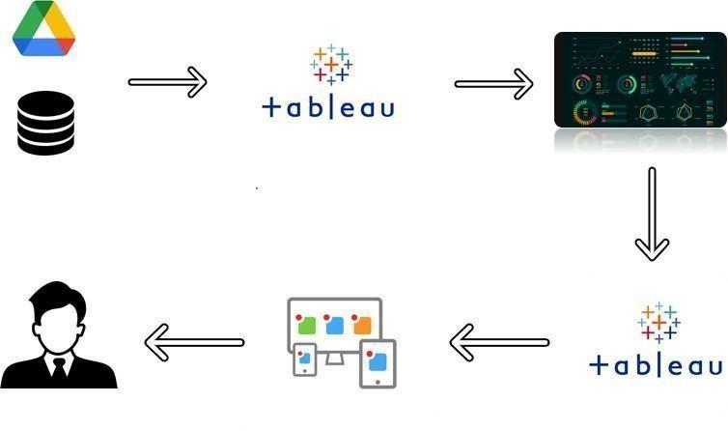

**2. PROBLEM DEFINITION & DESIGN THINKING:**

***2.1 EMPATHY MAP:***

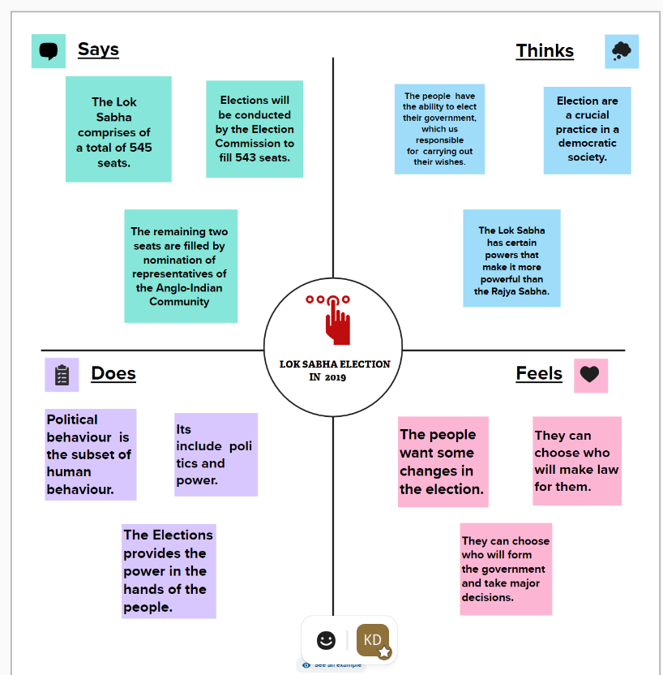

***2.2 IDEATION & BRAINSTORMING MAP:***

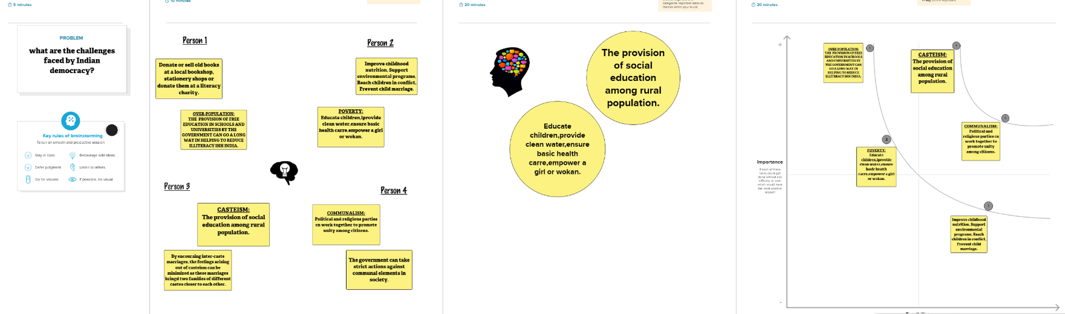

*3. RESULT:*

***For empathy map:***

* [*An empathy map*](https://www.mural.co/blog/empathy-mapping)*helps describe the aspects of a user's experience, needs and pain points. This template allows you to quickly understand your users’ experience and mindset.*

*FOR BRAINSTORMING:*

* *Brainstorming provides a free and open environment that encourages everyone within a team to participate in the creative thinking process that leads to problem solving. Prioritizing volume over value, out-of-the-box ideas are welcome and built upon, and all participants are encouraged to collaborate, helping each other develop a rich amount of creative solutions*.

**4. ADVANTAGES**

## **The empathy map template helps you:**

* ***Gain a holistic view of your users by considering what they say, do, feel, and think***
* ***Brainstorm with your team to cover all aspects of the user persona***
* ***Identify themes across the user experience***
* ***Discover opportunities for improvement***

## **The Brainstorm & idea prioritization template helps you:**

* ***Prepare for your brainstorming session***
* ***Define your problem statement***
* ***Collect ideas and gather feedback from everyone***
* ***Group ideas by theme***
* ***Prioritize your solutions and get aligned on next steps***

**5. DISADVANTAGES:**

DISADVANTAGES OF EMPATHY MAP:

***They are designed to capture the needs and perspectives of a specific audience, but may not capture the needs and perspectives of other stakeholders. For example, an empathy map created for customers may not capture the needs and perspectives of employees or suppliers.***

DISADVANTAGES OF BRAINSTORMING:

***Brainstorming is a popular technique for generating and evaluating ideas in a team setting. It can help you find creative solutions, foster collaboration, and stimulate innovation. However, brainstorming also has some drawbacks, such as groupthink, social loafing, and information overload.***

**6. APPLICATIONS:**

*EMPATHY MAP:*

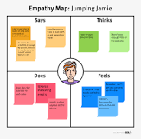

* ***Empathy maps are flexible. They can be useful at various times throughout the design process, including: Before research has happened, to plan and shape future studies. During research, to capture***
* ***users' needs, attitudes, and experiences***

***BRAINSTORMING:***

* ***This is usually used in the beginning stages of a project, when the possibilities for the project have not yet been clearly defined. It is also a very useful way to come up with creative ideas in product development or production methods. Advertising and marketing objectives are also a popular application.***

**7.RESULTS:**

* **Creating Dashboard, Story using Tableau and analyzing Candidates of 2019 Lok Sabha Elections.**

## [**Analysis of the contesting candidates in General Election 2019**](https://prsindia.org/theprsblog/analysis-of-the-contesting-candidates-in-general-election-2019)

*SHEET-1*

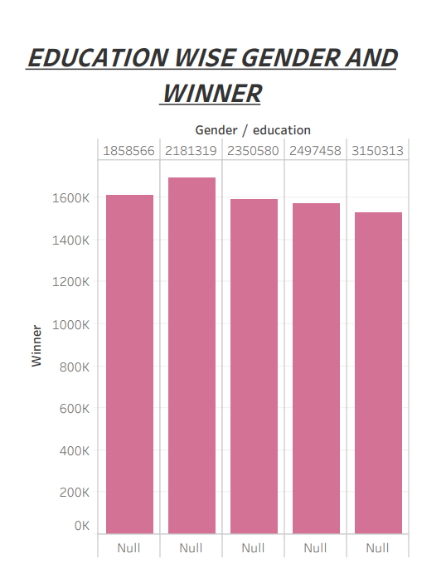

***SHEET-2***

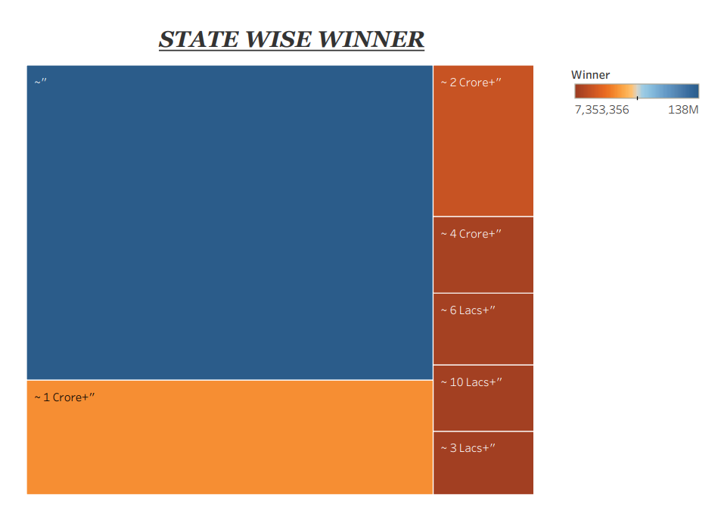

***SHEET-3***

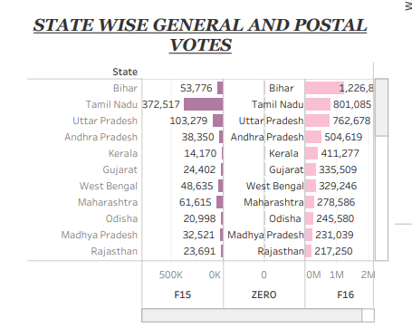

***SHEET-4***

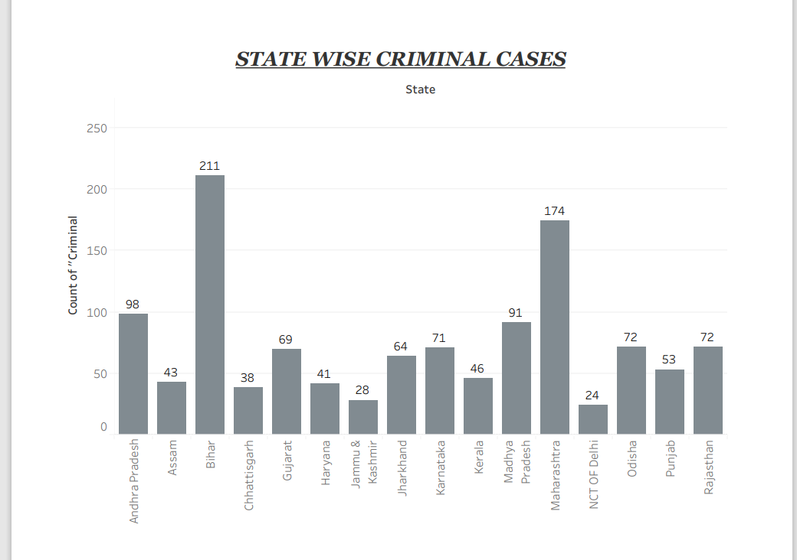

***SHEET-5***

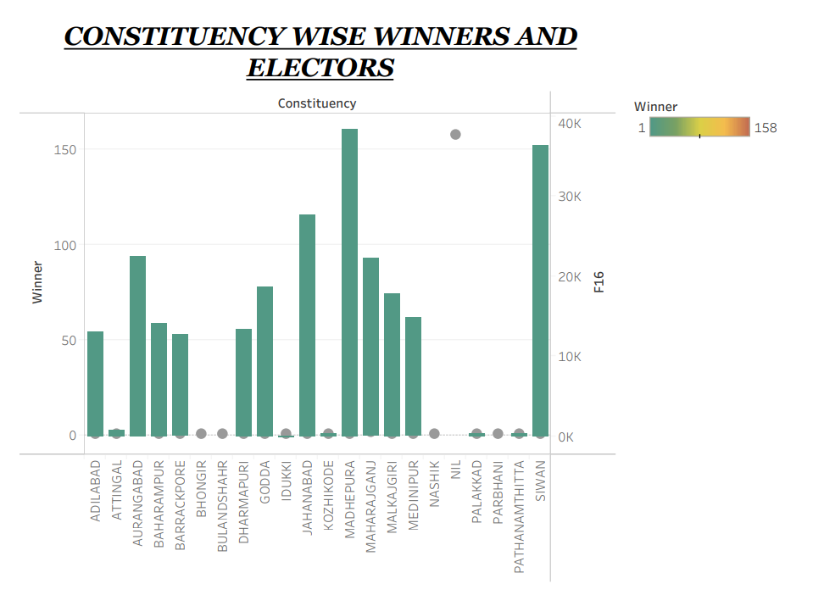

***SHEET-6***

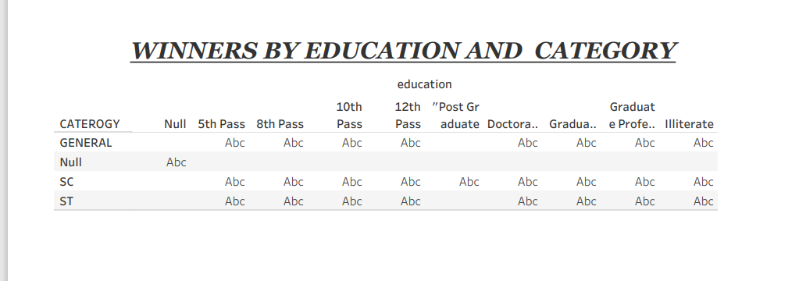

*SHEET-7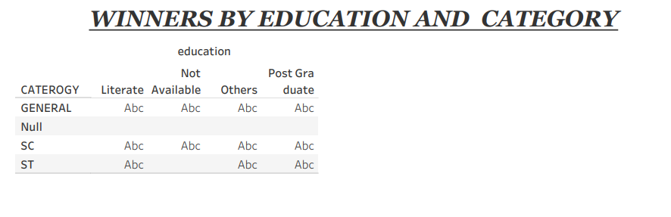*

*SHEET-8*

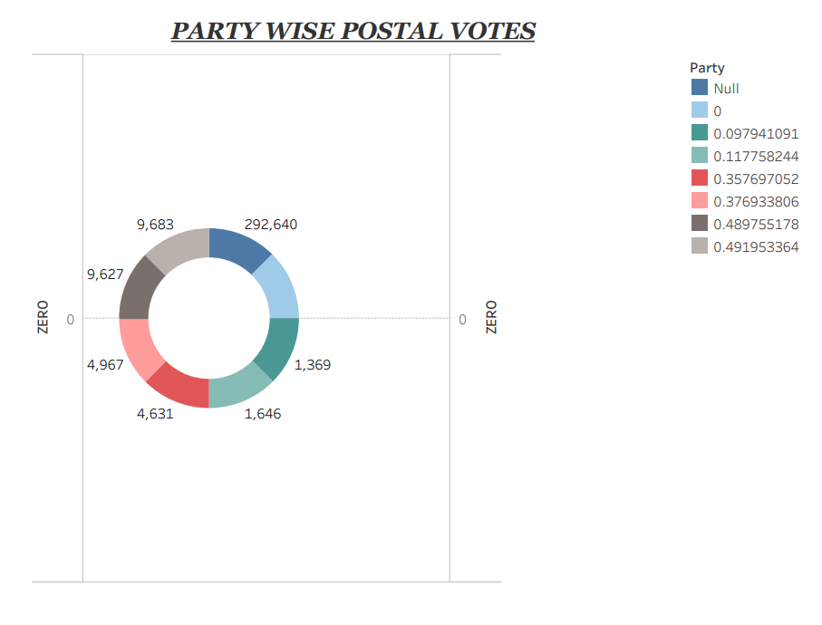

**DASHBOARD:**

**(POLITICAL JUGGERNAUTS: A QUANTITATIVE ANALYSIS OF CANDIDATES IN THE 2019 LOK SABHA ELECTIONS)**

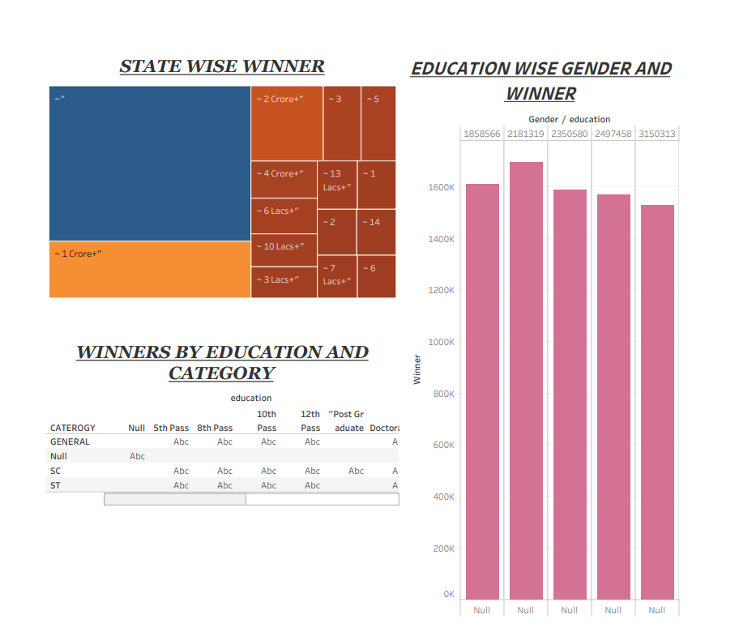

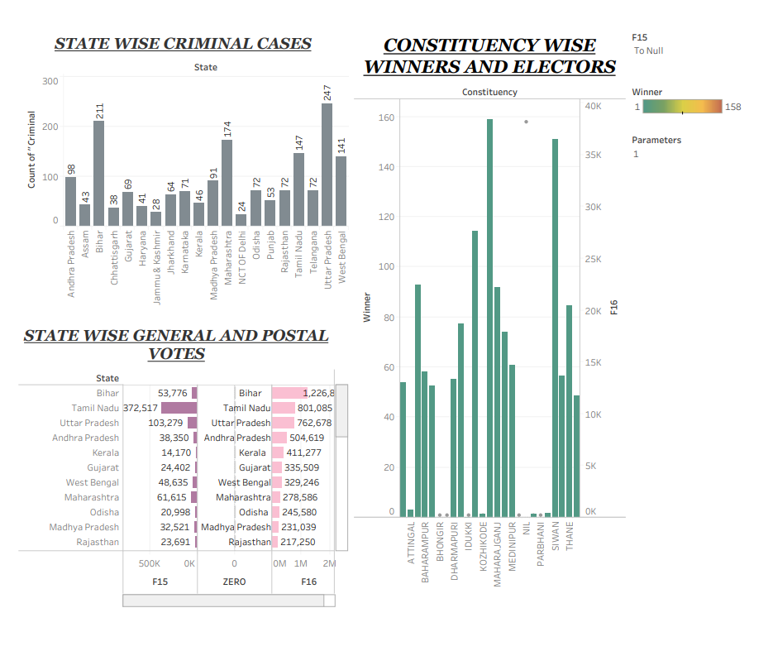

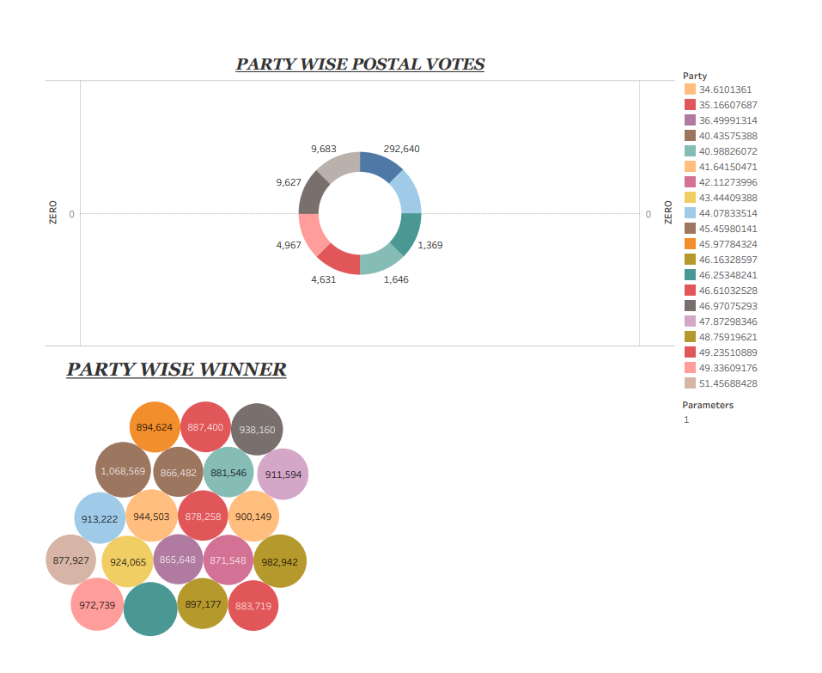

**STORY:**

**(POLITICAL JUGGERNAUTS: A QUANTITATIVE ANALYSIS OF CANDIDATES IN THE 2019 LOK SABHA ELECTIONS)**



